Interest and Principal Payment Calculation - Full Answer

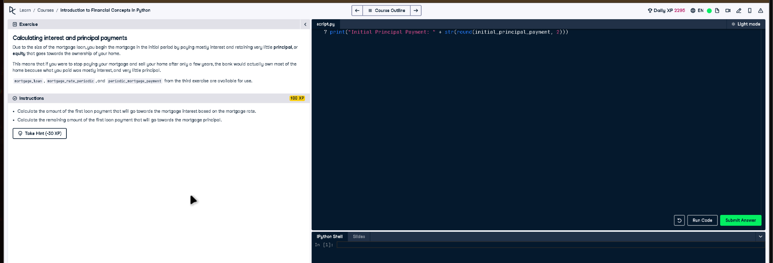

# Full Code Answer:

# Given variables  
# mortgage_loan, mortgage_rate_periodic, and periodic_mortgage_payment are provided.  
  
# Calculate initial interest payment  
initial_interest_payment = mortgage_loan * mortgage_rate_periodic  
  
# Calculate initial principal payment  
initial_principal_payment = periodic_mortgage_payment - initial_interest_payment  
  
print("Initial Interest Payment: " + str(round(initial_interest_payment, 2)))  
print("Initial Principal Payment: " + str(round(initial_principal_payment, 2)))

# Question:

Calculate the amount of the first loan payment that goes towards the mortgage interest and principal.

# 20-word Explanation (Question):

Each mortgage payment is split between interest and principal. The initial payment has a higher interest component and lower principal.

# Answer:

The interest portion is mortgage_loan * mortgage_rate_periodic, and the principal portion is periodic_mortgage_payment minus this interest.

# 20-word Explanation (Answer):

We calculate the interest portion first using the current balance and rate, then subtract it from the payment for principal.